
🎙️ The British 150 Podcast: Episode 4 - Transcript

(Intro music fades)

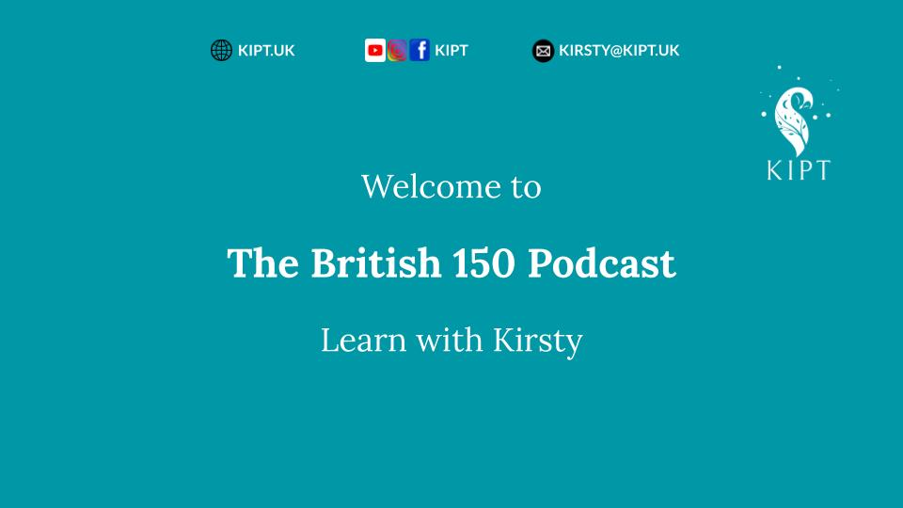

[Podcast Intro]

Hello! Welcome to The British 150 Podcast — your window into British music, culture and language.

I’m Kirsty, from KIPT — and my goal here is simple: to help you improve your English while sharing my love of British music.

In each episode of the podcast, we dive into a song from The British 150 Playlist — a journey through the music of these islands: Scotland, England, Wales and Ireland.

You can listen to the full playlist on YouTube or Spotify by searching for KIPT or The British 150.

Wherever possible, I’ve used the official releases — so if you’re on YouTube, please give your favourites a like and subscribe to the artist’s channel.

On Spotify, please follow the artists or add the tracks to your library — it supports the people who made the music we’re celebrating.

All of my research sources can be found in the blog post that accompanies each episode, at KIPT.UK/Blog.

You might discover a few interesting extras there too!

[Song Intro]

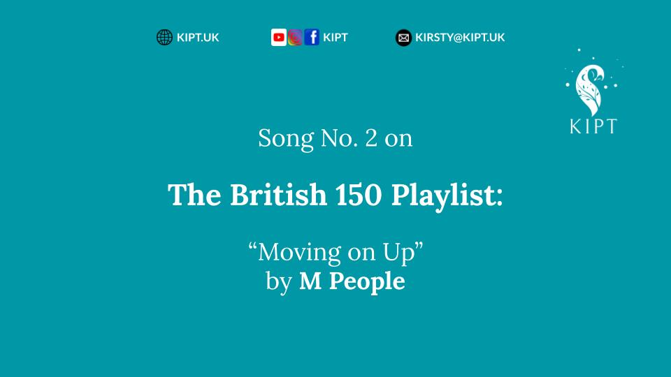

Last time, we smashed guitars with The Who.

This time, we’re smashing glass ceilings — and adding a sax solo for good measure!

Our first woman on the list, our first Black artist and one of Britain’s most unmistakable voices: Heather Small (MBE), leading M People.

At number four on The British 150 Playlist: “Moving On Up.”

[Sample #1]

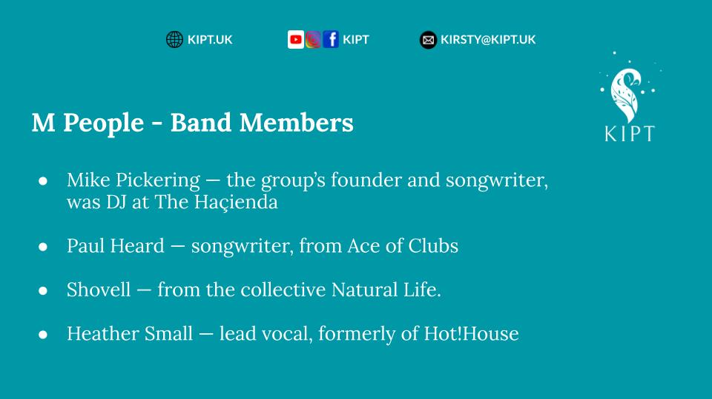

The band was made up of four key members:

- Mike Pickering — the group’s founder, whose nickname “Mike’s People” became M People. At the time, he was already well known as one of the original DJs at The Haçienda — the legendary Manchester club that helped shape Britain’s dance music scene.

- Paul Heard — previously a member of the acid-jazz outfit Ace of Clubs.

- Shovell — who had been part of the collective Natural Life.

- Heather Small — formerly of Hot! House, and the powerhouse voice that became instantly recognisable in 90s British dance-pop. (She later enjoyed a successful solo career, of course.)

“Moving On Up” was written by Mike Pickering and Paul Heard and was released on 13th September 1993.

It entered the UK Singles Chart at No. 4 and climbed to No. 2 the following week. At the same time, it topped the Music Week dance chart and even reached the Top 40 on the US Billboard Hot 100.

The track comes from the album Elegant Slumming, which debuted in the UK Top 5 and stayed on the chart until the following summer. The album went on to win the Mercury Music Prize in 1994.

All of which probably goes some way to explain why every British person of my generation seems to own a copy (or two) of that album!

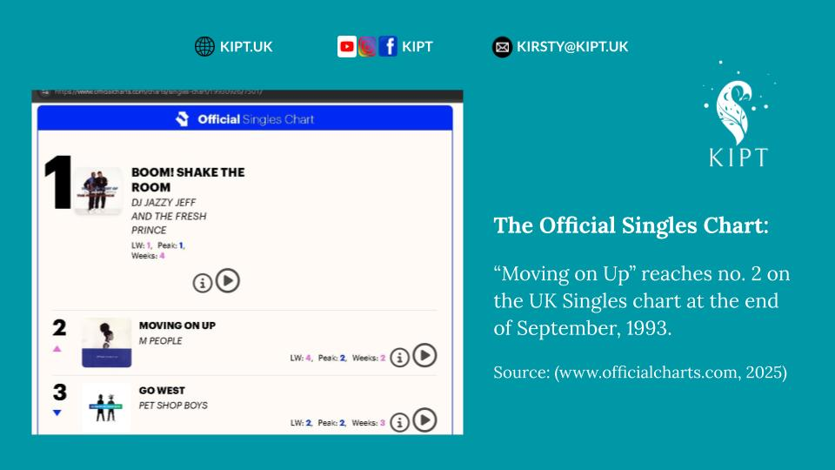

[Cultural & Musical Background]

Against a backdrop of early 90s optimism — post-Thatcher yet pre-Cool Britannia — Britain was quietly reshaping itself.

Club culture, long-standing global influences and a more visible diversity were redefining what the nation sounded like; and pop music changed with it.

M People emerged at this crossroads, blending house, soul and pop into a sound that was both sophisticated and accessible.

They were part of the wave that made dance music not only radio-friendly, but emotionally resonant — you could dance, snog, cry and feel cultured all at the same time!

M People became the feel-good soundtrack to social mobility — people who were quite literally “moving on up” in life.

Their sound captured the energy of a Britain reinventing itself, where hope and ambition were starting to replace decades of austerity and a lingering cynicism.

As Larry Flick of Billboard put it in his review, the band “deftly blends state-of-the-charts club trends with a reverence for classic Motown and R&B sounds.”

We must give Larry his due here: “state of the charts” is a neat little twist on the idiom, state of the art — meaning the newest, sharpest, most up-to-date. In chart terms, that’s high praise indeed.

In a similarly glowing review, Robert Hilburn of the Los Angeles Times called “Moving On Up”, “a glorious dancefloor record – as spirited a declaration of independence (from a bad relationship) as Gloria Gaynor's “I Will Survive’.”

It's worth noting that all of the major reviews I found were written by men — though, having grown up in that era, that fact didn’t exactly blow my mind.

For me, “Moving On Up” was the first song of that kind I’d heard since “I Will Survive”… which, for the record, came out in 1978.

That’s an awfully long wait for another anthem of female independence!

To understand the song’s power at this time, we need to recall what Britain looked like for women in the early 1990s.

Back then, the office ‘banter’ alone could make you long for one of those air-locked decontamination showers you see in sci-fi movies.

There were still few women in Parliament and workplace policies on equality and harassment were only just beginning to take shape.

So when Heather Small sang “I’m moving on up”, she wasn’t just leaving a man — she was rising above a system that hadn’t yet caught up with her confidence.

When the Spice Girls burst onto the scene a few years later shouting “Who do you think you are?”, it felt as though Heather had already asked that question — and answered it, too!

Heather’s was the voice that told women they could walk away from what didn’t serve them and still rise higher!

Let’s just say, before the platform shoes and pigtails, Heather Small had already done the heavy lifting.

This is where pop music becomes more than entertainment — it is where we can witness expressions of the national mood, class movement and shifts of identity.

[Linguistic & English-Learning Points]

Lyrically, “Moving On Up” is a masterclass in assertive language — direct without cruelty, confident without aggression.

The narrator — a woman speaking to a man — lays out her reasons for ending the relationship with clarity and grace.

The whole theme and chorus revolve around the phrasal verb moving on.

So, what is a phrasal verb?

Well, a phrasal verb is a two, or three-word combination:
A verb and a preposition, which together have an idiomatic or figurative meaning.
In other words, you can’t always interpret the phrase literally.

Let’s take a closer look at some examples from the lyrics.

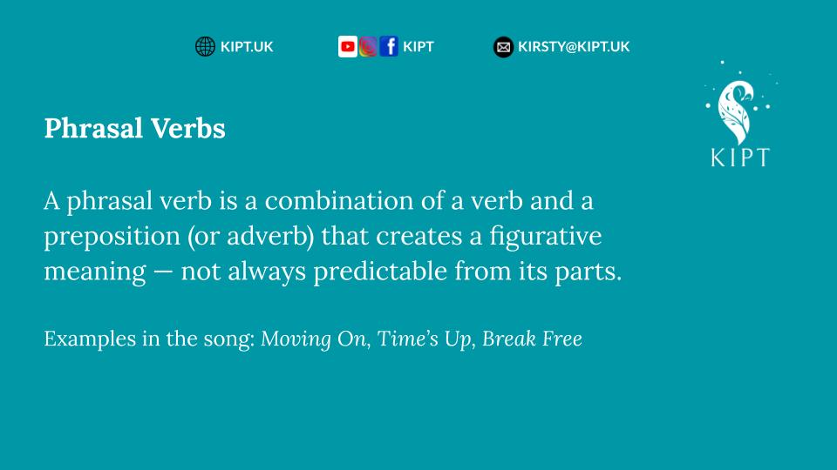

Think about moving on - it does suggest some kind of movement, doesn’t it? Walking, running, or simply going from one place to another.

But the ‘on’ here doesn’t mean physically moving forward - it stands in for ‘along the way’, or ‘further forward in your life’.

So in this song, moving on means emotionally progressing past a situation, rather than walking away in the literal sense.
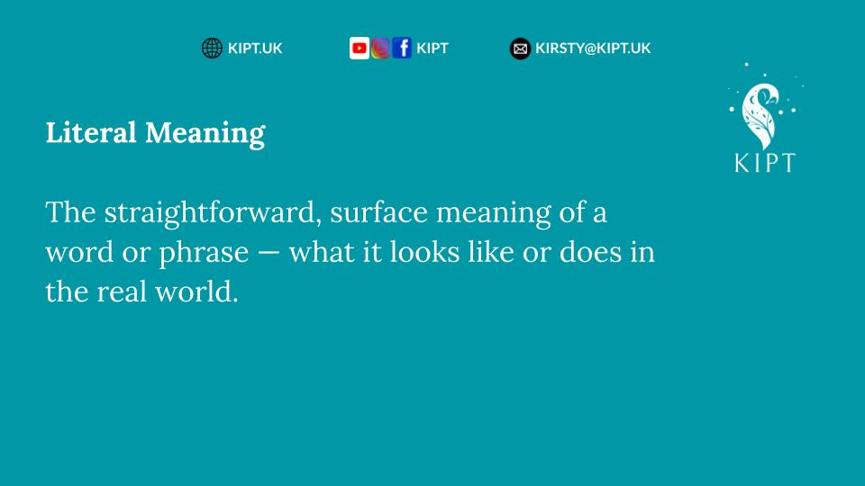
Some more examples of phrasal verbs and idiomatic meanings follow:

- “Your time is up” – the phrasal verb "time is up" or time’s up means the time allowed for something has ended; it is over. It’s often used to signal finality or accountability.
- “You took a sip from the devil’s cup” – a biblical leaning idiom, meaning to choose a destructive or unethical path, even when you know better.

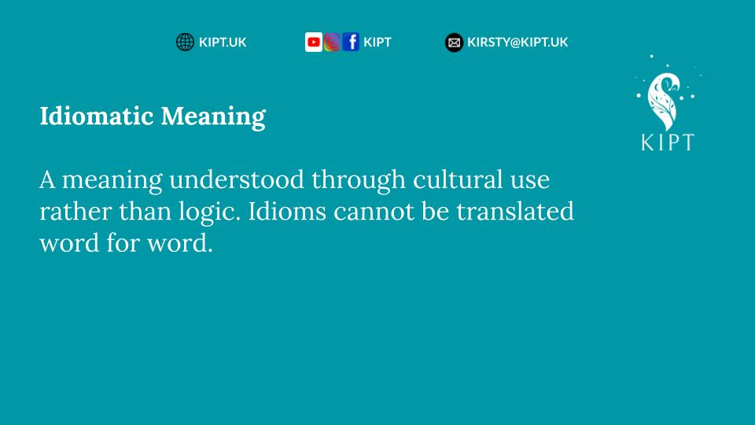

- “Who do you think you are?” – an idiomatic and rhetorical question, suggesting someone shows arrogance or overconfidence; it's a challenge against inflated self-importance.
- “Take it like a man… if that’s what you are.” – this idiom challenges both pride and masculinity, implying that the partner has failed to live up to either.
- “I’m moving on up” – an idiom expressing growth, renewal and independence.
- “You’re moving on out” – a reversal of the same phrase; it is firm, decisive and unambiguous.
- “Time to break free” – break free is a phrasal verb meaning to escape restraint or limitation, often used metaphorically to express liberation or empowerment.
- “Nothing can stop me” – unshakable resolve and independence comes through in abundance here.

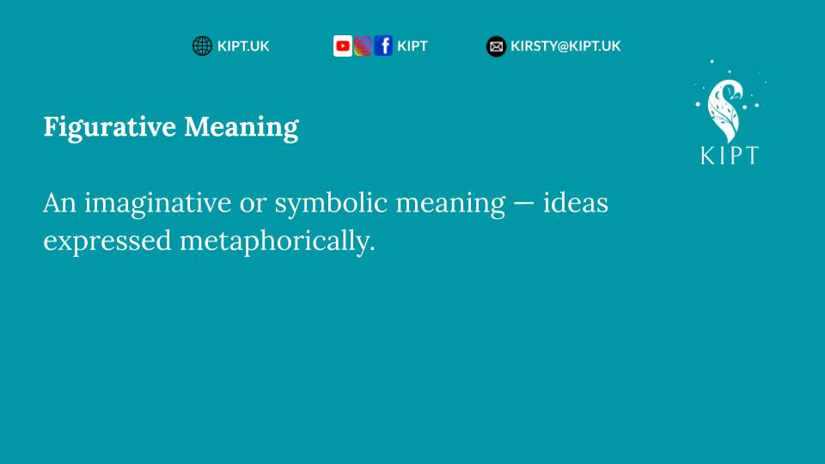
Notice how these phrasal verbs are flexible: they adapt easily to different tenses while retaining their figurative meaning.

Later in the song, Heather sings:

- “They brag a man has walked in space,
But you can’t even find my place” -To brag means to boast or exaggerate achievements; the two lines together highlight a sharp contrast between human ambition and personal failure. I really admire the choice of vocabulary and syncopation here. Personally, I find these lines hilarious!
- And finally, “This time you’ve gone too far.” Not idiomatic, but powerful — it sets a boundary that was known, yet clearly crossed.

Each of these lines builds the tone of empowerment: calm, assertive and unmistakably British in its understated confidence.

Heather Small’s vocal delivery amplifies this message — clear, rhythmic and full of conviction.

This single is English worth studying: diction, phrasing, emotional restraint; all in balance.

[Outro & Reflection]

While “My Generation” (discussed in Episode 3) channelled rebellion into confrontation, “Moving On Up” channels that same revolutionary energy into self-progression.

The 60s defied the old order; the 90s rose above it.

One said we won’t grow up and the other said we’re growing.

M People went on to record other deeply meaningful songs: “Search for the Hero” became a national anthem for perseverance and Heather’s solo hit ”Proud” later became the soundtrack for both the London 2012 Olympic bid and an Oprah Winfrey show!

What strikes me most about “Moving On Up” is that it’s not just about leaving a man — it’s about claiming space.

Small sang with a certainty that was still rare for women in British pop and rarer still for a Black woman fronting a mainstream band. This was before girl power was packaged and sold.

Heather’s voice was woman power — raw, unbranded and real. To this day, I love it when I hear her voice and I immediately know — that’s Heather Small! She’s distinctive!

If you haven’t been reading my blog, you won't know! But, one of the rules of The British 150 Playlist is simple: the songs must be unique, unmistakable and culturally relevant.

By the way, if you haven’t heard it yet, you should listen to M People, “One Night in Heaven” - as it very nearly took this spot.

(Outro music rises)

Don't forget, for more background information on M People, or any of the songs and artists featured in The British 150 Podcast, you can find all the extras at KIPT.UK/blog.

Until the next time — keep listening, keep learning and keep moving on up!

(Music fades out)

